**KAMPALA PARENTS’ SCHOOL 2004**

**END OF YEAR ASSESSMENT, 2018**

**APTITUDE – TOP CLASS**

**Name: ______________________________ Group: ________**

**Date: ________________________________________________**

1. **Oral work**
2. What is the name of your school?
3. How many eyes do you have?
4. Blood is colour ___________.
5. How does the police help us?
6. How many days make a week?
7. Which animal gives us milk?
8. What do you use to brush your teeth?
9. We use ears for ___________.
10. What is the colour of your hair?
11. Where do Moslems go on Friday?
12. **Read and draw the needs of people.**

|  |  |  |  |
| --- | --- | --- | --- |
|  |  |  |  |
| education | food | clothes | medicine |
|  |  |  |  |
| water | transport | money | shelter |

1. 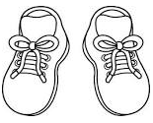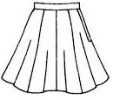**Name the things we wear.**

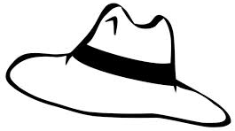

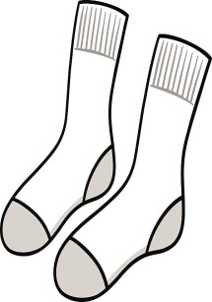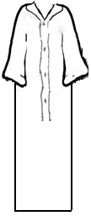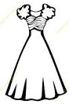_______________ _______________ _______________

_______________ a pair of stockings _______________

**skirt , hat , dress , kanzu , shoes , a pair of stockings**

1. 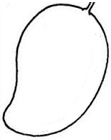**Match the fruits.**

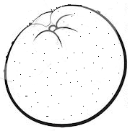apple

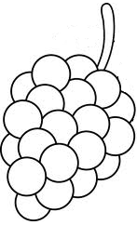banana

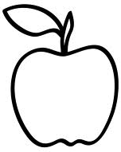pineapple

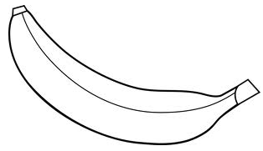grapes

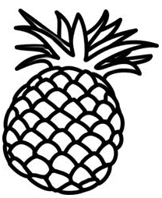mango

orange

1. 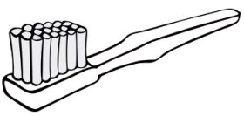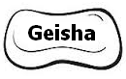**Name the things we use to clean our body.**

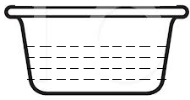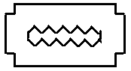 s o a p ________________

________________ ________________

**( water , razorblade , toothbrush , soap )**

1. **Name these important people.**

|  |  |  |
| --- | --- | --- |
|  |  |  |
| teacher |  |  |
|  |  |  |
|  |  |  |

**( farmer , teacher , driver , doctor , chef , policeman )**

1. **Match the domestic animals to their homes.**

cow sty

dog hutch

cat shed

rabbit kraal

sheep basket

pig kennel

1. **Name their young ones.**

cow c a l f

dog ______________

cat ______________

pig ______________

sheep ______________

rabbit ______________

**( lamb , puppy , kitten , bunny , piglet )**

1. **Draw the dangerous things.**

|  |  |  |
| --- | --- | --- |
|  |  |  |
| water | nails | razorblade |
|  |  |  |
| fire | snake | broken bottle |